Hands-on chapter 4

1.

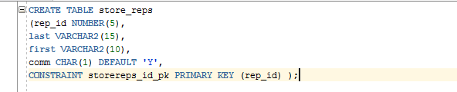

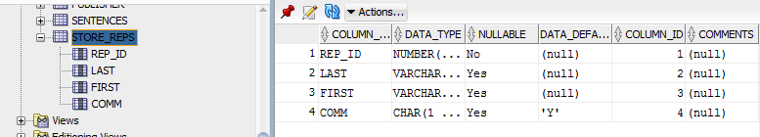



2.

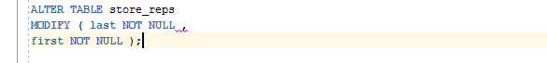

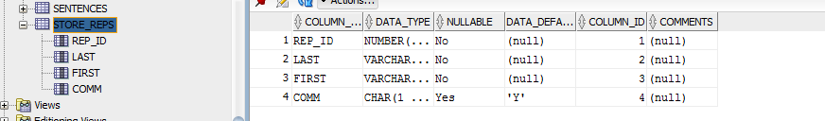

3.





4.

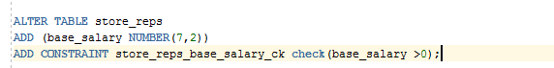



5.

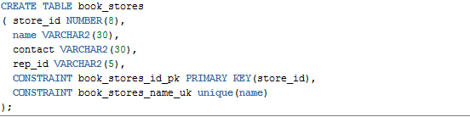



6.

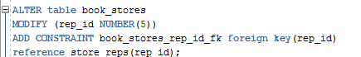



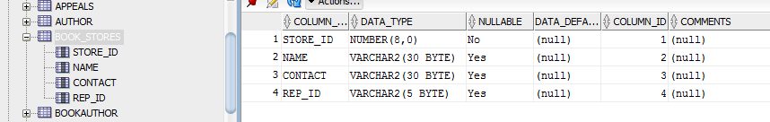

7.





8.

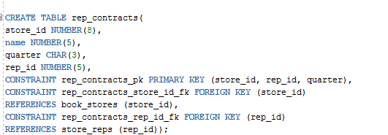

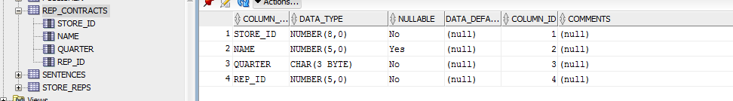

9.

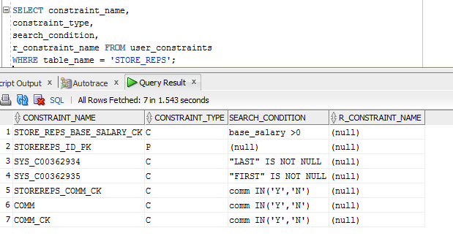

10.



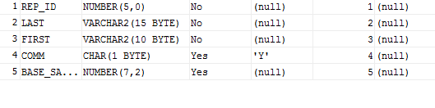

All code

CREATE TABLE store_reps

(rep_id NUMBER(5),

last VARCHAR2(15),

first VARCHAR2(10),

comm CHAR(1) DEFAULT 'Y',

CONSTRAINT storereps_id_pk PRIMARY KEY (rep_id) );

ALTER TABLE store_reps

MODIFY ( last NOT NULL ,

first NOT NULL );

ALTER TABLE store_reps

ADD CONSTRAINT comm_ck CHECK (comm IN('Y','N'));

ALTER TABLE store_reps

ADD (base_salary NUMBER(7,2))

ADD CONSTRAINT store_reps_base_salary_ck check(base_salary >0);

CREATE TABLE book_stores

( store_id NUMBER(8),

name VARCHAR2(30),

contact VARCHAR2(30),

rep_id VARCHAR2(5),

CONSTRAINT book_stores_id_pk PRIMARY KEY(store_id),

CONSTRAINT book_stores_name_uk unique(name)

);

ALTER table book_stores

MODIFY (rep_id NUMBER(5))

ADD CONSTRAINT book_stores_rep_id_fk foreign key(rep_id)

reference store_reps(rep_id);

ALTER table book_stores

ADD CONSTRAINT book_stores_rep_id_fk foreign key(rep_id)

reference store_reps(rep_id) on delete cascade;

CREATE TABLE rep_contracts(

store_id NUMBER(8),

name NUMBER(5),

quarter CHAR(3),

rep_id NUMBER(5),

CONSTRAINT rep_contracts_pk PRIMARY KEY (store_id, rep_id, quarter),

CONSTRAINT rep_contracts_store_id_fk FOREIGN KEY (store_id)

REFERENCES book_stores (store_id),

CONSTRAINT rep_contracts_rep_id_fk FOREIGN KEY (rep_id)

REFERENCES store_reps (rep_id));

SELECT constraint_name,

constraint_type,

search_condition,

r_constraint_name FROM user_constraints

WHERE table_name = 'STORE_REPS';

alter table store_reps disable constraint store_reps_base_salary_ck;

alter table store_reps enable constraint store_reps_base_salary_ck;